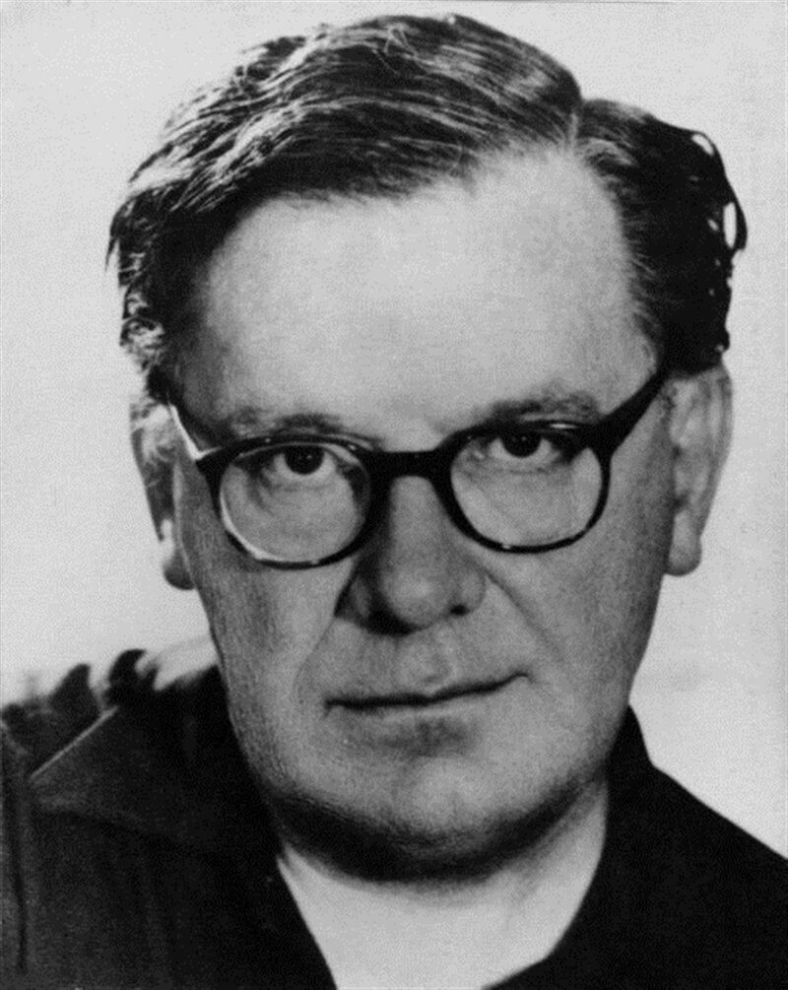

NIKOS EGGONOPOULOS (1907 – 1985) was a Greek surrealist painter, poet and professor at the University of Engineering
Dreams and fantasy were the sources that fed his creative passion. Bright colors dominate his work.
He is inspired by Greek mythology, the Byzantine tradition and elements of the more general Greek tradition and history. In his works, Greek history is intertwined with the fantastic and the different time periods become one. He - unlike other surrealists - did not seek a break with the past, but a creative union between the present and the past.
…………………………
Surrealism: revolutionary artistic movement, in which artists depicted absurd scenes, allowing the unconscious to express itself. Surrealism works feature the element of surprise, unexpected juxtapositions and discontinuity.

